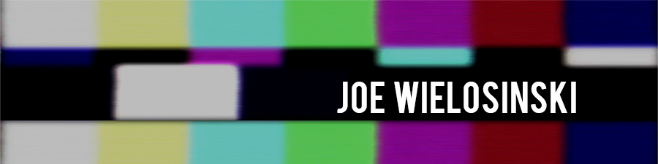
(708) 528-0360 | JClemens415@Gmail.com

EXPERIENCE

Web Content Producer/Editor – Purdue University Northwest 2015-2016
- Design graphics and layout for the Department of Communication and Creative Arts.
- Shoot/Edit short videos for sharing on social media platforms.
- Control content for website and social media platforms.
- Increased Facebook likes by 42 percent from first semester to second, including a 91 percent increase from day one until the present.
- Highest post reach was 12 percent larger than any from the previous school year; increased post reach by 4.11 percent from fall to spring semester.

Visiting Instructor in Communication – Purdue University Northwest 2014-2016
- Taught upper level courses in Visual Communication, Radio/TV Performance, Sports Broadcasting and Photography.
- Manage partnership between the Communication Department and WJOB radio station.
- Develop and supervise student live streams of university sporting events.
- Implement innovative teaching methods, including: YouTube videos to support lecture material, leading tours at The Art Institute of Chicago, and provide opportunity for location photography.
- Coordinate studio tours and research new equipment for the Communication Department.
- Collaborate with colleagues on other Communication Department events.

SELECT VIDEO EXPERIENCE

- “WNBA Chicago Sky Food Drive” –Producer/Camera/Editor
- “WNBA Chicago Sky Fitness Festival” – Producer/Camera/Editor
- “WNBA Chicago Sky Ticket Renewal” – Additional Camera
- “PNW Department of Communication and Creative Arts Fast Facts” – Producer/Editor
- “PNW at BEA 2016” - Editor
- “PUC at BEA 2015” - Producer/Editor
- “Swishing on a Star” Producer (winner of a Gold AVA Award)
- “Plight of the Peregrines” Editor/Assistant Director (Winner of a Chicago/Midwest Student Emmy Award

EDUCATION

Governors State University | Degree in Film and Digital Imaging

Purdue University Calumet | Degree in Communications with an option in Broadcasting

SKILLS
- Independent filmmaker, with official film festival selections in Illinois (Best Feature Film Award), Louisiana, Massachusetts, North Carolina, Texas, and the Philippines. Winner of AVA, Communicator EMPixx, and Videographer awards
- Excellent command of Mac/PC, Adobe Premiere/Photoshop and Final Cut Pro, Video encoding and codecs, Microsoft Office/Google Docs, YouTube/Vimeo, WordPress and Final Draft with proficiency in After Effects
- Canon DSLR’s (5D Mark II/ III, 7D, T3I, T5I), lenses and Black Magic Cinema Camera (2.5K)
- Leader, well-organized, works well independently and with a team, excellent memory

